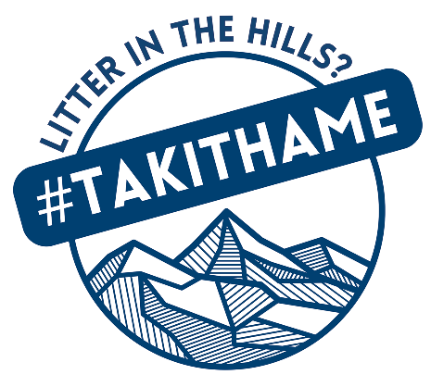

Press Release Date: 3rd October 2024

#TakItHame!
Joining together to keep the hills we love litter free
Mountaineering Scotland, Loch Lomond & The Trossachs National Park and the National Trust for Scotland teamed up on Sunday 29th September 2024 for the first ever TakItHame litter pick event on Ben Lomond, one of Scotland’s most popular Munros.
Staff, volunteers and members of Loch Lomond Mountain Rescue joined together to raise awareness of littering in the hill and managed to clear a fantastic 10 bags of rubbish from Ben Lomond’s slopes over the course of the day. Volunteers also chatted to other hillwalkers, encouraging them to take their litter home and offering free reusable Mountaineering Scotland #TakItHame bags.
Kenny Auld, Head of Visitor Services at Loch Lomond & The Trossachs National Park Authority, said: “Millions of people visit the National Park every year and it is vital that we encourage them to do so responsibly and sustainably. Planning ahead by bringing a bag to take litter away is one of the easiest ways for visitors to protect nature and wildlife in the National Park.
“We are proud to support the TakItHame campaign and will continue to work with partners to ensure visitors are informed and inspired to make climate and nature-friendly choices when they spend time at popular sites like Ben Lomond.”
Mountaineering Scotland President, Anne Butler, added: “Not only did we leave the mountain path in a much better state than we found it, but the event enabled us to engage with, and educate, the hill walking community on the importance of personal responsibility and creating a culture of environmental protection.”
Mountaineering Scotland’s TakItHame campaign was launched five years ago with the aim encouraging the hillwalking, climbing and mountaineering community to help reduce litter in our hills.
To find out more about the campaign, visit www.mountaineering.scot/conservation/campaigns/tak-it-hame
ENDS
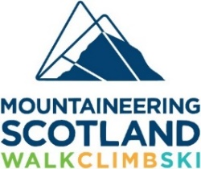
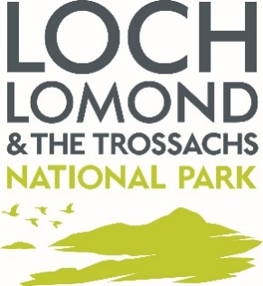

An image is available to download here.
For further information, quotes, and images, please contact:
Fiona McNicol, Communications Officer, Mountaineering Scotland
E: fiona@mountaineering.scot | 01738 493 941

About:
Mountaineering Scotland
Mountaineering Scotland is the membership and representative organisation for hill walkers, climbers, mountaineers and ski tourers in Scotland, with a membership of 16,000 individual and club members and 150 affiliated clubs. We aim to inspire and encourage people to enjoy the benefits of walking, climbing and ski touring and provide information and skills training to mountain users to promote safety, self-reliance and responsible access in Scotland’s mountains and climbing venues.
Web: www.mountaineering.scot |X (formerly Twitter): @Mountain_Scot
Facebook: @MountaineeringScotland | Instagram: @mountaineeringscotland

Loch Lomond and the Trossachs National Park Authority
Loch Lomond and the Trossachs National Park is Scotland’s oldest National Park covering 720 sq. miles. The Park and those who live, work within and visit the Park are facing unprecedented challenges of the climate emergency and nature loss. The National Park Authority provides leadership and collaborates with partners and communities to restore and enhance the natural assets, biodiversity and ecosystems within Loch Lomond and the Trossachs National Park, while maximizing benefits for the environment, climate, and people.
Web: www.lochlomond-trossachs.org | X (formerly Twitter): @lomondtrossachs
Facebook: @lomondtrossachs | Instagram: @lomondtrossachs

National Trust for Scotland
Established in 1931, the National Trust for Scotland is Scotland’s largest conservation charity and cares for, shares and speaks up for Scotland’s magnificent heritage. Over the last 90 years the Trust has pioneered public access to and shared ownership of some of the most magnificent buildings, collections and landscapes in Scotland. It cares for more than 100 sites, from ancient houses to battlefields, castles, mills, gardens, coastlines, islands, mountain ranges and the plants and animals which depend upon them. Scotland’s largest membership organisation, the National Trust for Scotland relies on the support of its members and donors to carry out its important work.

Web: www.nts.org.uk | X (formerly Twitter): @N_T_S
Facebook: | Instagram:

